JPA 1對多表格資料處理
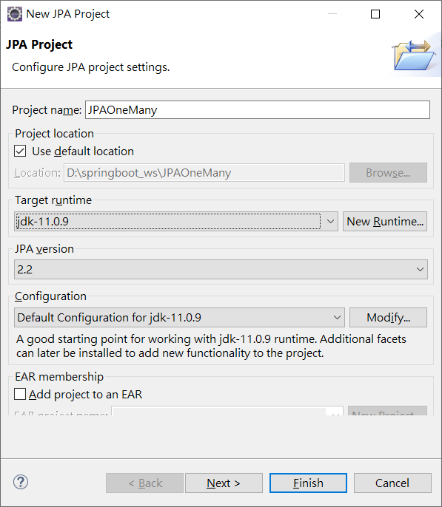
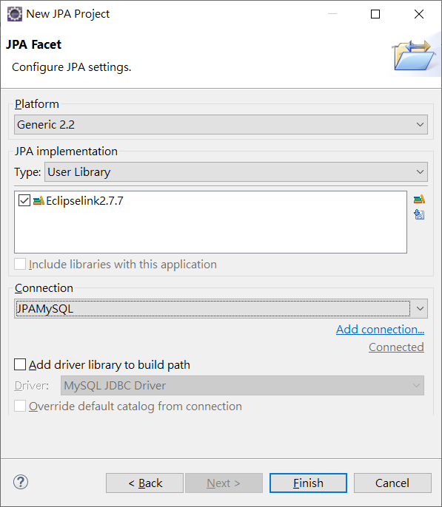

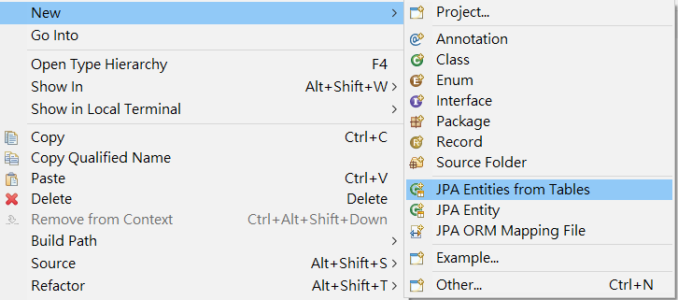
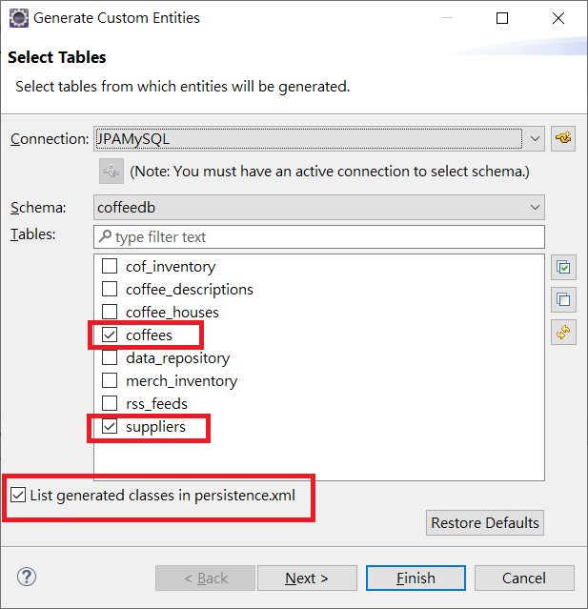
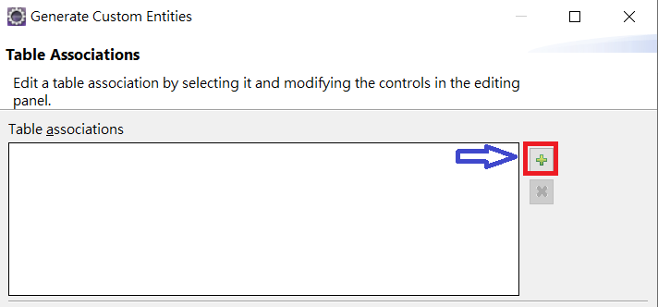
點擊加號設定表格關聯(Table Associations)
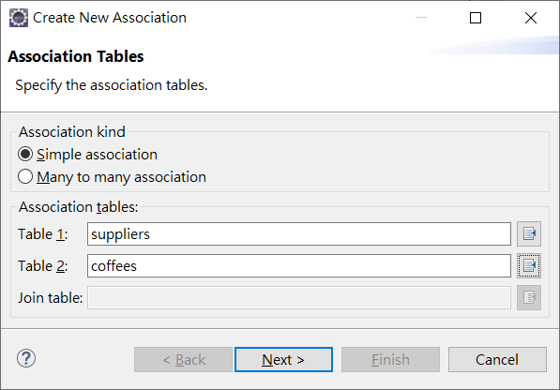
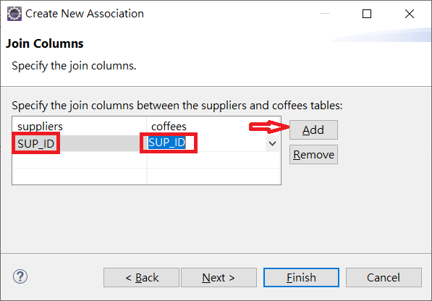
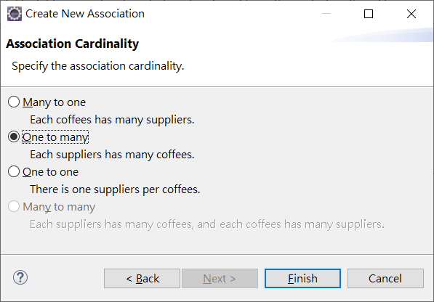
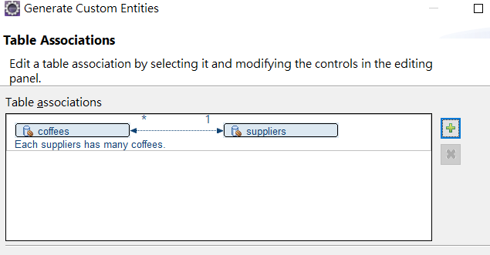
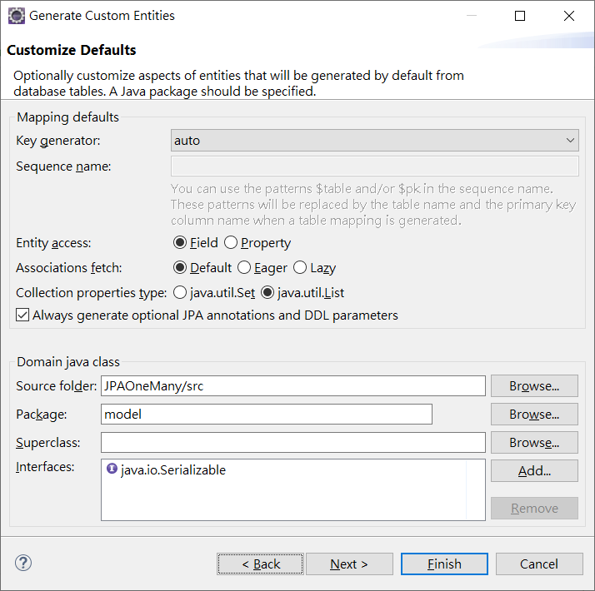
Supplier.java

package model;
import java.io.Serializable;
import javax.persistence.*;
import java.util.List;

@Entity
@Table(name="suppliers")
@NamedQuery(name="Supplier.findAll", query="SELECT s FROM Supplier s")
public class Supplier implements Serializable {
private static final long serialVersionUID = 1L;
// KEY 需要自行加入
@Id
@Column(name="SUP_ID")
private int supId;
private String city;
private String state;
private String street;
@Column(name="SUP_NAME")
private String supName;

private String zip;

//bi-directional many-to-one association to Coffee
@OneToMany(mappedBy="supplier" , cascade = CascadeType.PERSIST)
private List<Coffee> coffees;

public Supplier() {
}

public String getCity() {
return this.city;
}

public void setCity(String city) {
this.city = city;
}

public String getState() {
return this.state;
}

public void setState(String state) {
this.state = state;
}

public String getStreet() {
return this.street;
}

public void setStreet(String street) {
this.street = street;
}

public String getSupName() {
return this.supName;
}

public void setSupName(String supName) {
this.supName = supName;
}

public String getZip() {
return this.zip;
}

public void setZip(String zip) {
this.zip = zip;
}

public List<Coffee> getCoffees() {
return this.coffees;
}

public void setCoffees(List<Coffee> coffees) {
this.coffees = coffees;
}

public Coffee addCoffee(Coffee coffee) {
getCoffees().add(coffee);
coffee.setSupplier(this);

return coffee;
}

public Coffee removeCoffee(Coffee coffee) {
getCoffees().remove(coffee);
coffee.setSupplier(null);

return coffee;
}

public int getSupId() {
return supId;
}

public void setSupId(int supId) {
this.supId = supId;
}

}

Coffee.java
package model;

import java.io.Serializable;
import javax.persistence.*;
import java.math.BigDecimal;

@Entity
@Table(name="coffees")
@NamedQuery(name="Coffee.findAll", query="SELECT c FROM Coffee c")
public class Coffee implements Serializable {
private static final long serialVersionUID = 1L;
@Id
@Column(name="COF_NAME")
private String cofName;

private BigDecimal price;
private int sales;
private int total;

//bi-directional many-to-one association to Supplier
@ManyToOne
@JoinColumn(name="SUP_ID", referencedColumnName="SUP_ID")
private Supplier supplier;

public Coffee() {
}

public String getCofName() {
return this.cofName;
}

public void setCofName(String cofName) {
this.cofName = cofName;
}

public BigDecimal getPrice() {
return this.price;
}

public void setPrice(BigDecimal price) {
this.price = price;
}

public int getSales() {
return this.sales;
}

public void setSales(int sales) {
this.sales = sales;
}

public int getTotal() {
return this.total;
}

public void setTotal(int total) {
this.total = total;
}

public Supplier getSupplier() {
return this.supplier;
}

public void setSupplier(Supplier supplier) {
this.supplier = supplier;
}

}
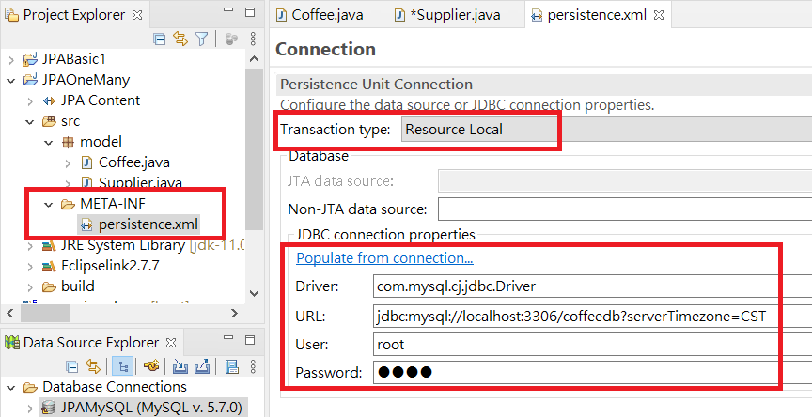
<?xml version="1.0" encoding="UTF-8"?>
<persistence version="2.2" xmlns="http://xmlns.jcp.org/xml/ns/persistence" xmlns:xsi="http://www.w3.org/2001/XMLSchema-instance" xsi:schemaLocation="http://xmlns.jcp.org/xml/ns/persistence http://xmlns.jcp.org/xml/ns/persistence/persistence_2_2.xsd">
<persistence-unit name="JPAOneMany" transaction-type="RESOURCE_LOCAL">
<class>model.Coffee</class>
<class>model.Supplier</class>
<properties>
<property name="javax.persistence.jdbc.url" value="jdbc:mysql://localhost:3306/coffeedb?serverTimezone=CST"/>
<property name="javax.persistence.jdbc.user" value="root"/>
<property name="javax.persistence.jdbc.password" value="1234"/>
<property name="javax.persistence.jdbc.driver" value="com.mysql.cj.jdbc.Driver"/>
</properties>
</persistence-unit>
</persistence>

package model;

import javax.persistence.EntityManager;
import javax.persistence.EntityManagerFactory;
import javax.persistence.Persistence;
import java.math.BigDecimal;
import java.util.ArrayList;
public class OneMany {

public static void main(String[] args) {
EntityManagerFactory emf = Persistence.createEntityManagerFactory("JPAOneMany");
EntityManager em = emf.createEntityManager();

em.getTransaction().begin();
Supplier sp = new Supplier();

sp.setCity("Taipei");
sp.setSupName("Gjun");
sp.setState("TW");
sp.setStreet("Kung Yuan Road");
sp.setZip("101");
sp.setSupId(1);

Coffee c1=new Coffee();
c1.setCofName("Flavor A");
c1.setPrice(new BigDecimal(200.0));
c1.setSales(10);
c1.setTotal(5);
c1.setSupplier(sp);

Coffee c2=new Coffee();
c2.setCofName("Flavor B");
c2.setPrice(new BigDecimal(100.0));
c2.setSales(11);
c2.setTotal(6);
c2.setSupplier(sp);

ArrayList<Coffee> list = new ArrayList<>();
list.add(c1);
list.add(c2);
sp.setCoffees(list);
em.persist(sp);

em.getTransaction().commit();
em.close();

}

}

